Logistic Regression Analysis of Hotel Reservations
Ashley Horner
Student ID: 0117741877
Western Governor’s University
D214 Capstone – Task 3

Problem Statement and Hypothesis
Hotels globally have a fundamental business need to ensure that they book as many of their rooms as possible to remain profitable. To do this, given that online booking and free cancellation policies could leave vacancy rates unacceptably high, a hotel may need to overbook to mitigate the effect. Managing overbooking strategies necessitates an ability to predict the likelihood of a reservation being cancelled. This goal of this study is to identify which variables from a hotel reservation could be used to predict whether the reservation will be kept or cancelled. The hypothesis is that a Logistic Regression model can be created that can predict hotel reservation cancellations with at least 60% accuracy.

Data Analysis Process
The data used for the study is “Hotel Revenue,” publicly available from Kaggle.com (Krishnadas, 2022). This dataset contains 141,950 records with global hotel reservations booked via various channels spanning from 2018 through 2020. Following data preparation, this data set contained 28 variables that included both categorical and continuous values describing the type of room reserved, when and how the reservation was made, the length of the stay, and a headcount of guests included in the stay. These were limited to only those records from Great Britain, bringing the record count for the study to 13,487. The dependent variable is a binary categorical value indicating yes or no for whether the reservation cancelled. For this analysis, both cancellations and no-shows were treated as cancellations since the effect of each is an empty room.
Data was prepared by the following:
- Missing values identified and associated columns removed from the study as they were categorical and not possible to impute.
- Data evaluated for outliers and extreme outliers imputed to the median.
- Static variables (like country) were removed since values are the same for all records.
- Multicollinearity addressed by removing independent variables that are too highly correlated or that are duplicative of the dependent variable.
- Chi Square Test and ANOVA applied to independent variables to identify which would be used for the initial model.
- Categorical variables that would be used for modeling were dummy-encoded.
- Feature reduction via Recursive Feature Elimination with Cross-Validation based on a Decision Tree Classifier.
- Reduced variable set split into training and test data set, using a 30% holdout for testing.

Summary of Findings
As a result of data preparation and analysis, it was identified that lead_time was the strongest predictor for reservation cancellation in a Logistic Regression model with an anticipated accuracy of 82%. This variable finding is consistent with a CatBoost study performed on similar data, further substantiating the relationship between lead_time and cancellations (Banza, 2020). The model was therefore trained on the lead_time variable. Testing the model on the test data produced an accuracy score of 80%. There were 3,247 true positives, 800 false negatives, 0 false positives, and 0 true negatives shown in the confusion matrix. The model does not predict kept reservations but does predict cancellations. A second model building strategy was used to verify the outcome, still Logistic Regression but via an alternative package. This alternative approach to the Logistic Regression model produced an accuracy score of 81%, consistent with the findings of the first model.

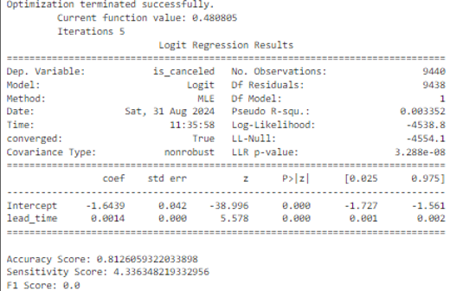
The model indicates that for each day that lead_time increases, the log odds of cancellation increase by 0.0014, or 0.14%. When lead_time is zero, the odds of cancellation baseline at 31.2%. When lead_time reaches 290 days, the odds of cancellation reach 50%.
log(p/(1-p))(lead_time=290) = -1.6439 + (0.0014*290) = -1.2379
log(p/(1-p))(lead_time=0) = -1.6439 + (0.0014*0) = -1.6439
-1.2379 – (-1.6439) = 0.406
Exp(0.406) = 1.500 = 50% increase
The statistical significance of the findings was tested via Log Likelihood Ratio Test and found to be significant with a p-value of 0.0. Based on a ROC Curve, the model also does perform better than chance.
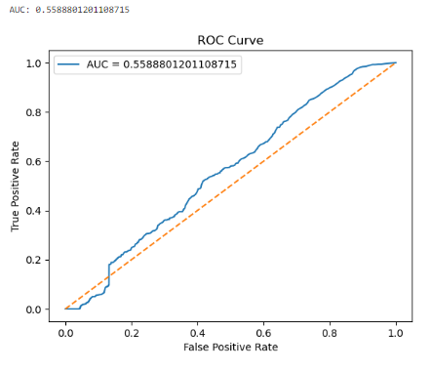
The findings of the study therefore confirm the hypothesis that hotel cancellations can be predicted with at least 60% accuracy based on the provided dataset.

Limitations of Techniques and Tools Used
The data set is limited to three years of data, which may not be enough to identify a long-term trend. Further, the years of data available include external events, specifically the COVID-19 pandemic and associated travel restrictions, that applied pressure to the travel industry and could have increased overall cancellations in ways that might not have presented in other years. Perhaps reservations made further in advance would have been kept if not for COVID-19 lockdowns.
The data set also does not account for additional demographic features of the customers for reservations, and as this data is unknown, more predictive or nuanced insights into what motivates a person to choose to cancel cannot be determined from the dataset provided.

Summary of Recommended Actions
The study confirms that reservations with a longer lead time can be used in a Logistic Regression model to reliably predict whether a cancellation is likely for a hotel reservation. This means that hoteliers could monetize this predictability by intentionally overbooking a percentage of their rooms based on how far in advance online reservations are made. Based on these results, a reasonable recommendation would be for business leaders to leverage their domain knowledge in addition to this predictive tool to decide how high an overbooking percentage is reasonable for their specific hotel given other factors not measured in this analysis. External factors and information could be paired with this analysis on lead times to maximize the occupancy rate of the hotel.

Expected Benefits of the Study
Of the Great Britain reservations studied, 1,045 of those have lead_time values greater than or equal to 290 days. This represents 7.75% of the data. In other words, at least 1,045 reservations have a 50% chance or higher of cancellation. Intentionally and somewhat aggressively overbooking these specific reservations could mitigate revenue lost by cancellation. The average daily rate of those bookings is £88, with an average stay of 6 nights, or £528. The average impact is therefore £557,760 if all those reservations were completed stays, £183,920 per year. A less aggressive overbooking strategy could be applied to those reservations with lead_time values between 145 and 290 days. These 4,024 reservations would have a cancellation likelihood in the 40% range, potentially salvaging up to £173,032 per year if 30% of those reservations were targeted for overbooking and converted to completed stays. The combination of these two strategies could potentially regain over £350,000 per year for the hotels in Great Britain.

References
Banza, Manuel. 2020. Predict Hotel Cancellations. Hospitalitynet. Retrieved August 4, 2024 from https://www.hospitalitynet.org/opinion/4099297.html

Krishnadas, Govind. 2022. Hotel Revenue. Kaggle.com. Retrieved August 4, 2024 from https://www.kaggle.com/datasets/govindkrishnadas/hotel-revenue

